Small Modular Reactors: Capsulizing Nuclear Power
Two of the most decisive factors against the adoption of nuclear energy are related to the amount of nuclear waste produced and their overall construction cost. In this context, Small Modular Reactors (SMRs) seem to be a viable choice over the typical large-scale Nuclear Power Plants that are operating in the present-day world.
As the name suggests, a Small Modular Reactor is a type of fission reactor that is smaller than the conventional nuclear power plants in size as well as capacity (about 350 MWe). Their compactness enables them to be manufactured in factory conditions and transported to the site for installation, thus reducing the financial burden associated with the on-site construction. In addition to the ease of construction, these reactor designs are especially beneficial for providing electricity to remote locations or for powering a small industrial grid.
A typical SMR design involves compacting the current generation large scale nuclear reactor technology, with the option of including newer technologies to obtain an integrated reactor design (as demonstrated by the figure). The compactness associated with this integrated architecture favours the use of passive safety systems that do not require additional components. This gives the SMRs an edge over the large nuclear reactors by facilitating large-scale factory manufacturing, improving the quality of the assembly and reducing the amount of on-site work. Additionally, their smaller size allows for a reduced, faster and more efficient testing and maintenance facility.

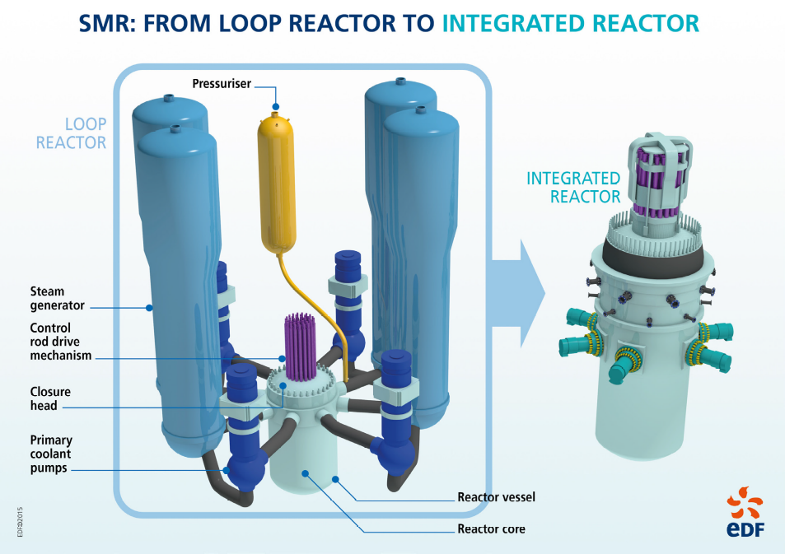
Compacting a full-scale nuclear reactor to obtain an integrated reactor design (source: EDF)

Ongoing projects associated with SMR technology
Numerous projects involving some of the biggest players such as NuScale Power (United States of America), Rolls-Royce (United Kingdom) and China National Nuclear Corp. (CNNC) are ongoing all over the world. To mention some of them:
- The floating nuclear power plant "Akademik Lomonosov": this 'working prototype' for a future fleet of floating nuclear power plants and on-shore installations consists of 2 units (of capacity 35MW each) based on the Russian-made SMR design KLT-40 that is similar to those used on icebreakers.
- The Finnish SMR district heating project: launched by the VTT Technical Research Centre in Finland, the project aims to develop a SMR intended for district heat production, thus phasing out the conventional energy resources.
- The NuScale Reactor Design of the USA: operated by NuScale Power, an Oregon-based energy start-up, this prototype reactor represents a light water reactor that’s 65 feet tall and 9 feet in diameter, and is housed in a containment vessel only slightly larger. Despite its small size, this reactor can produce up-to 60 megawatts of energy, which is about one-tenth the smallest operational reactor in the US today.
Despite their advantages, the overall contribution of SMRs to the global market for newly-built nuclear projects of the period 2020-2035 depends on factors such as successful licensing of the designs, establishment of their factory production and the associated supply chain.
Nevertheless, there is a tremendous potential for this technology to represent an alternative way forward for nuclear power development.

References:
- https://www.engineering.com/AdvancedManufacturing/ArticleID/20230/Small-Modular-Reactors-are-the-Future-of-Nuclear-Energy-Economic-Aspects.aspx
- https://www.oecd-nea.org/ndd/pubs/2016/7213-smrs.pdf
- https://www.sciencemag.org/news/2019/02/smaller-safer-cheaper-one-company-aims-reinvent-nuclear-reactor-and-save-warming-planet#
- https://www.wired.com/story/the-next-nuclear-plants-will-be-small-svelte-and-safer/

